**Client**: 2) The Questionnaire Backend to submit all the questions/answers for the services which is a lot of information to enter.

**WDP**:

Create question

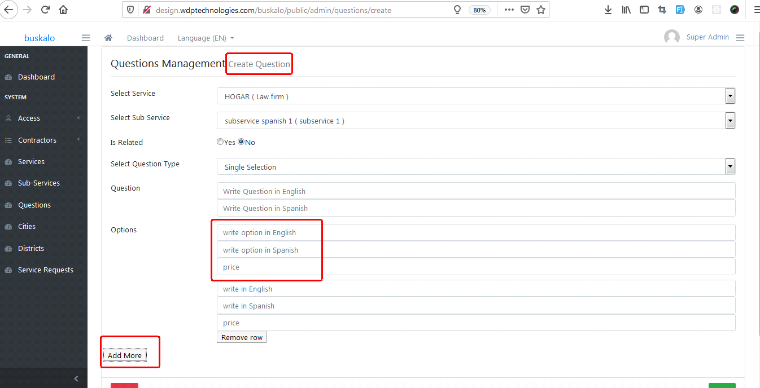

**BUSKALO:**

We seek that in the questionnaire options we can configure the price level and the factor, according to the document sent as lead's price

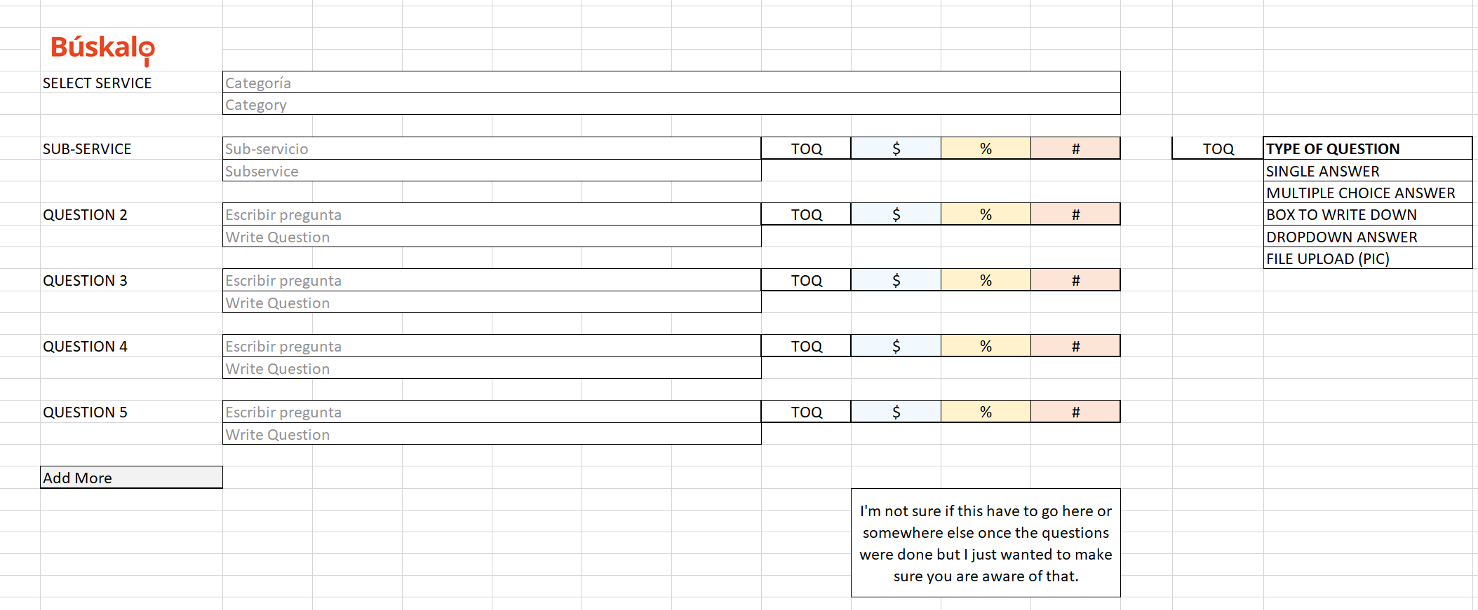

Example:

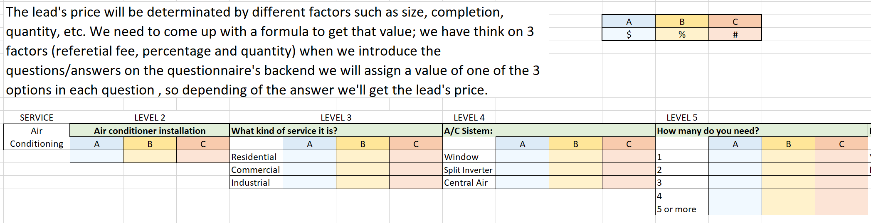

we suggest an implementation like this

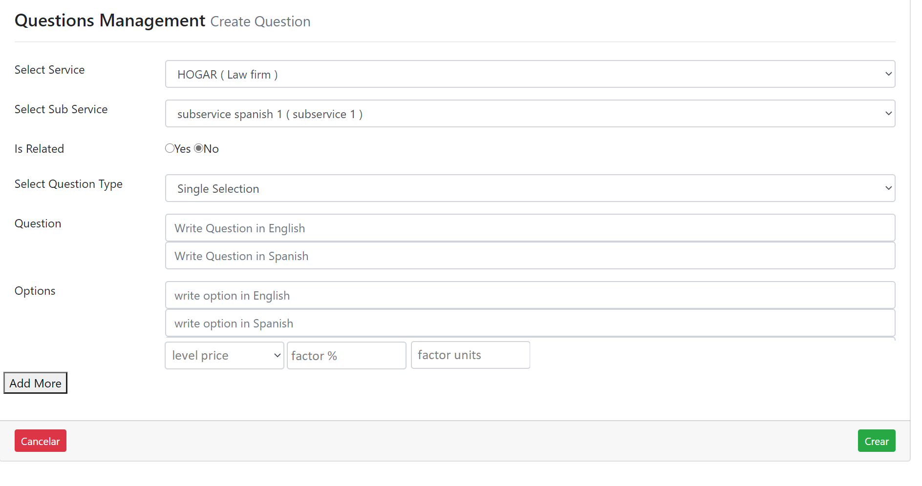

price level is a table to be entered:

